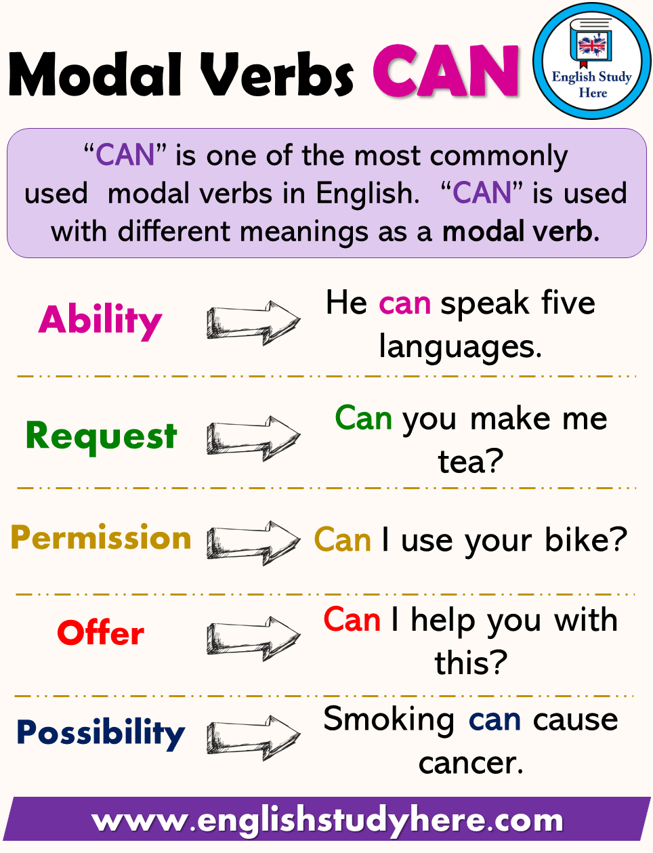

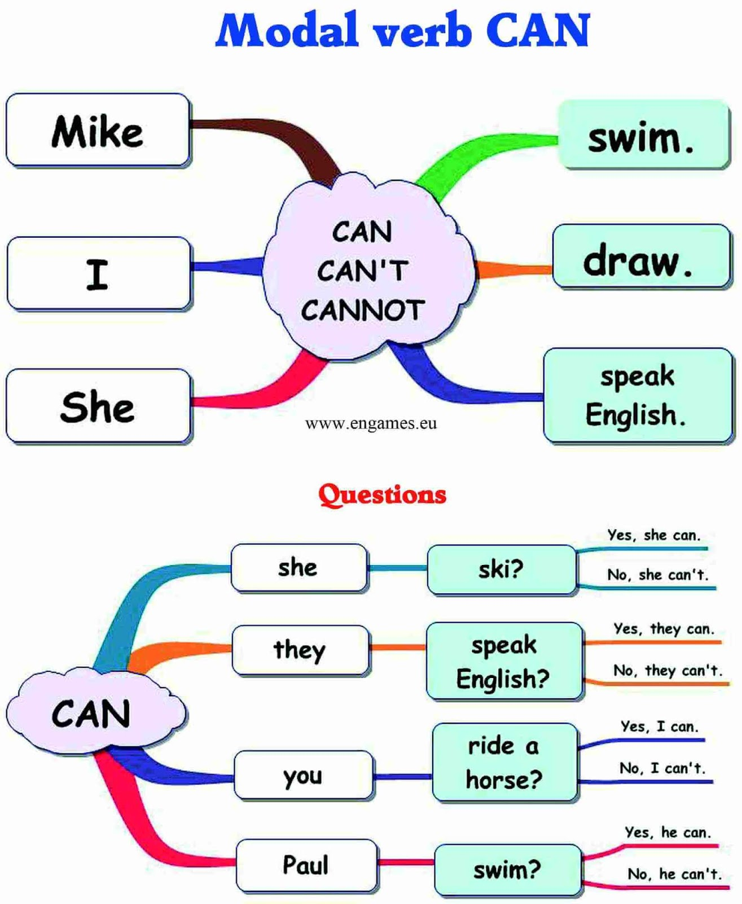

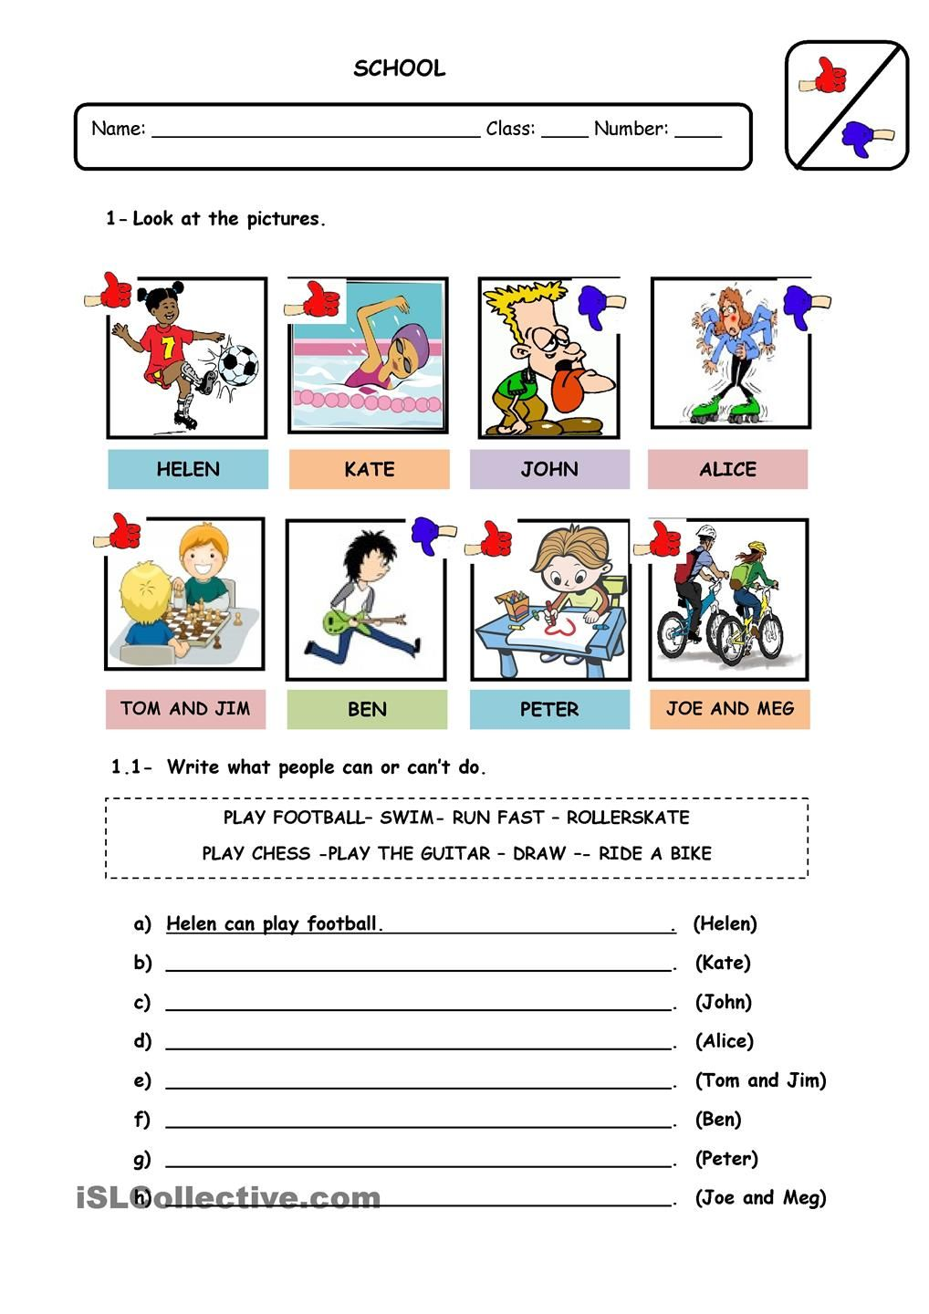

She can swim today

Jhon can exauted

She can do it

Tom and Jim can play chess

Ben can’t not play the guitar

Peter can draw

Joe and Meg can ride a bike

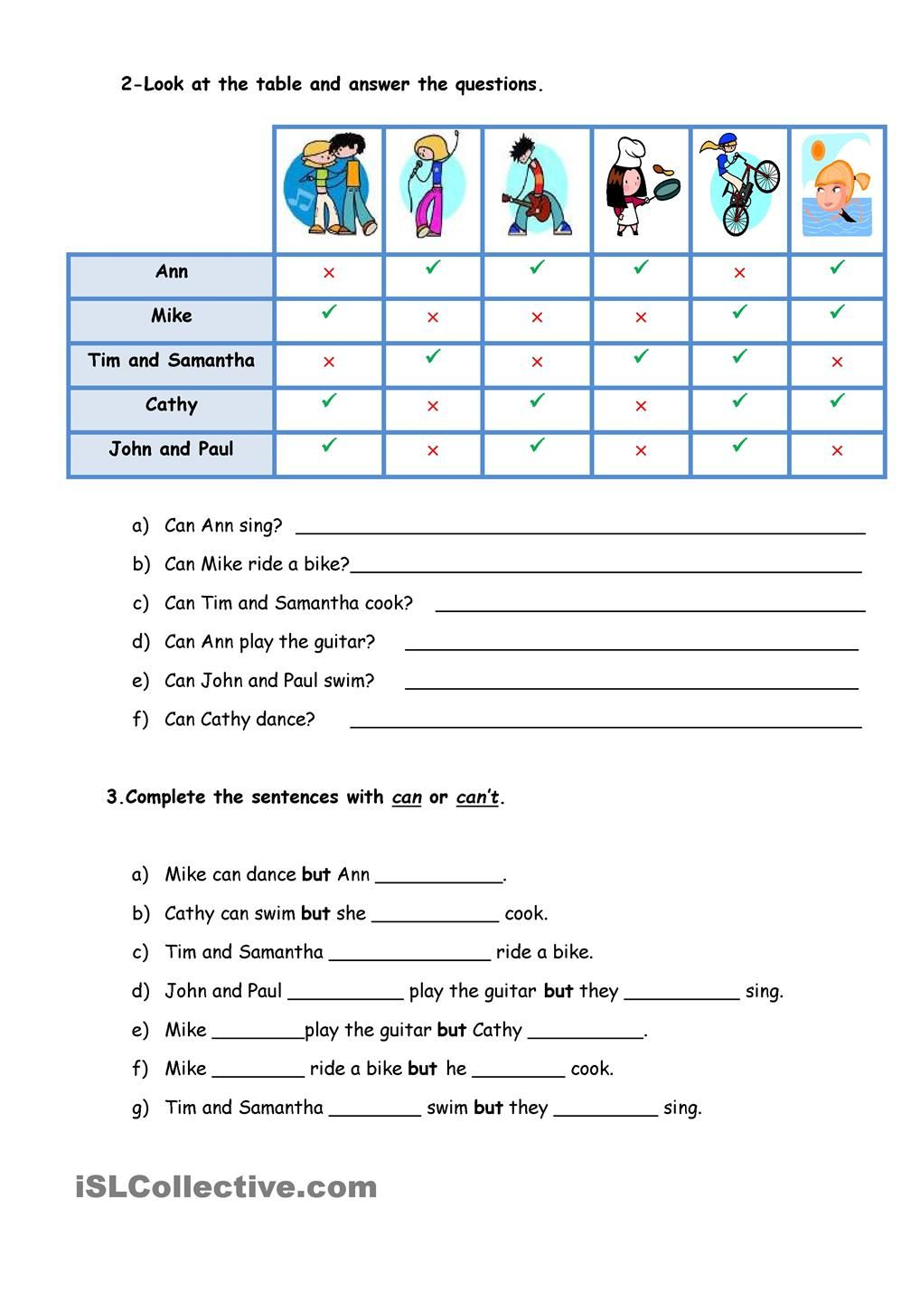

Can’t

Can’t

Can

Can can’t

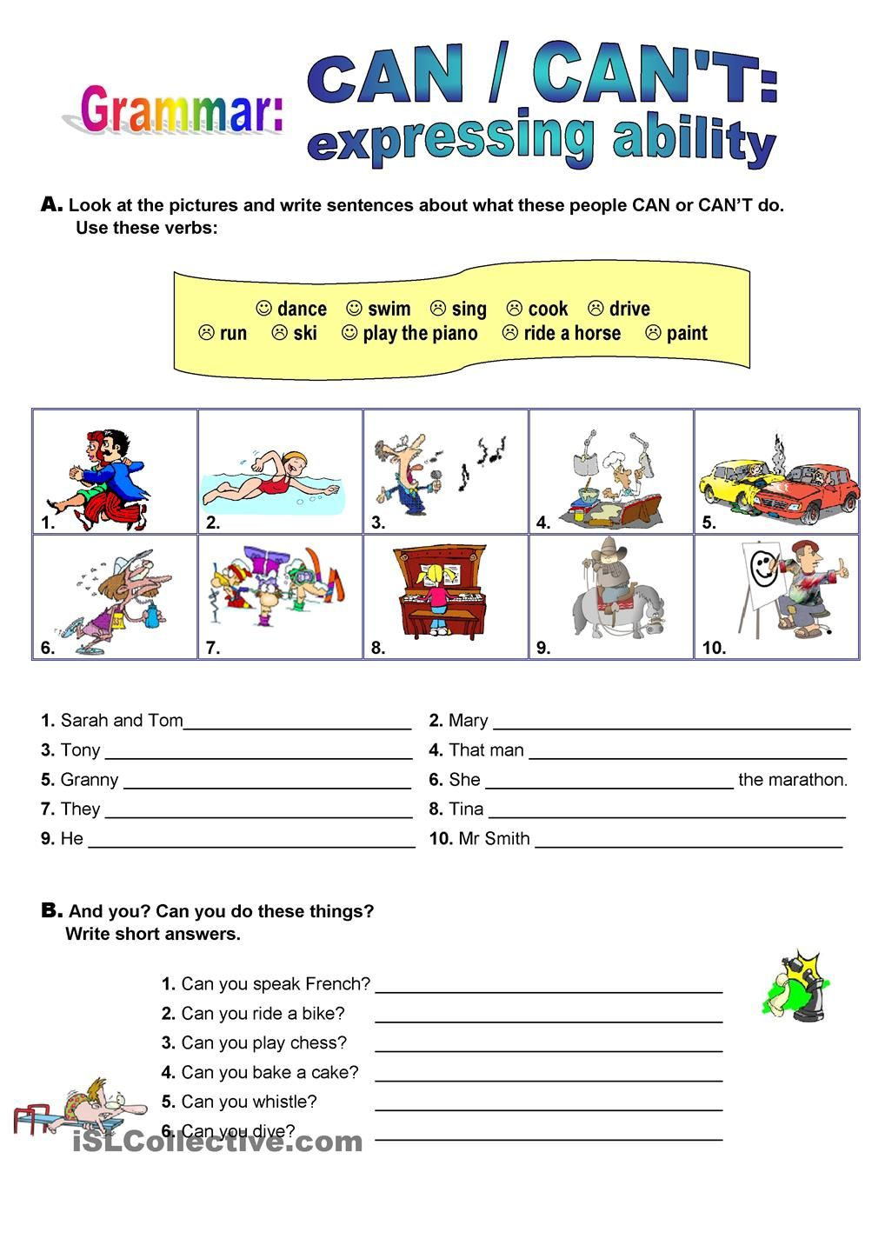

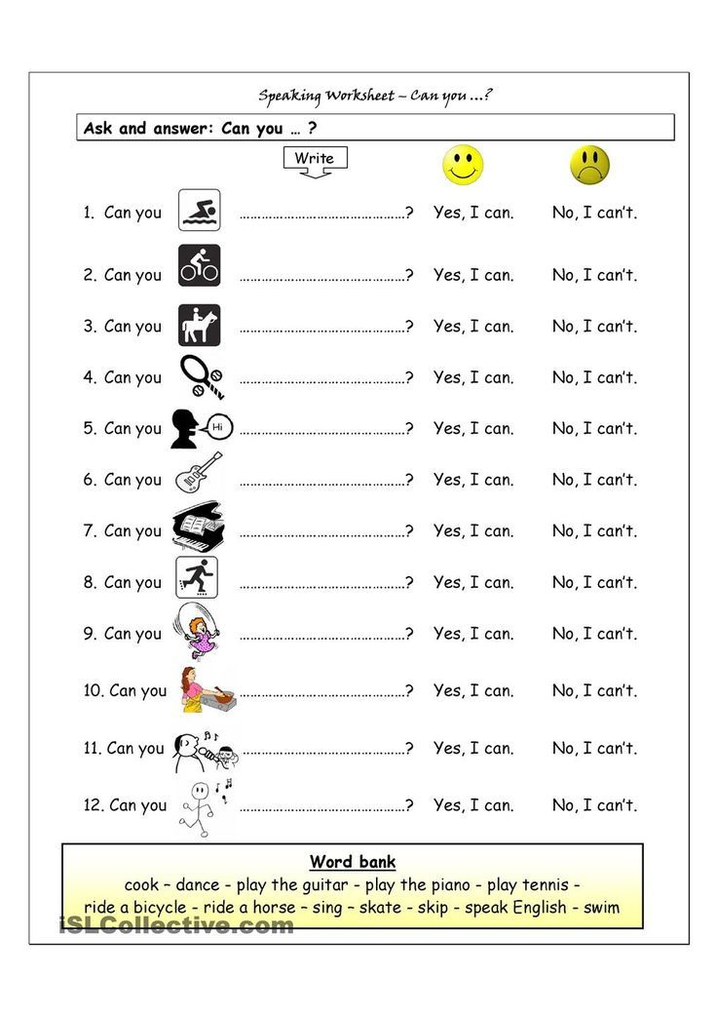

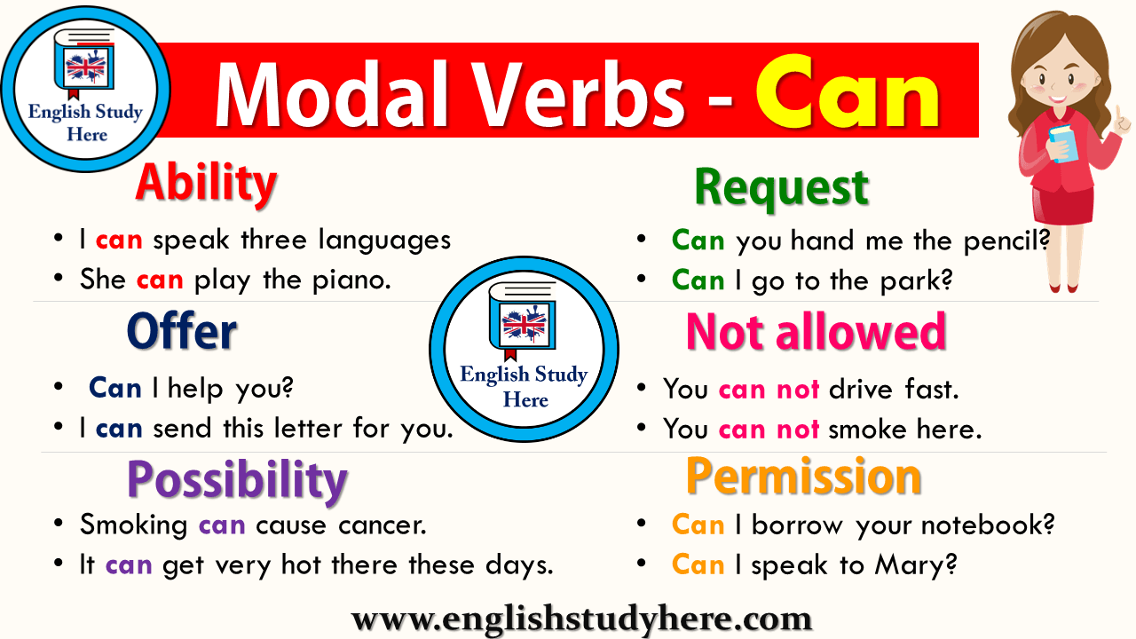

REMEMBER:

“YOU CAN SPEAK ENGLISH VERY WELL!”